Hellobot car handle remote control
1.Learning goals
In this lesson we will learn to use the Handle to remotely control the car.

2.Programming method
Mode 1 online programming: First, we need to connect the micro:bit to the computer by USB cable. The computer will pop up a USB flash drive and click on the URL in the USB flash drive: http://microbit.org/ to enter the programming interface. Add the Yahboom package https://github.com/lzty634158/HelloBot and https://github.com/lzty634158/GHBit to programming.
Mode 2 offline programming: We need to open the offline programming software. After the installation is complete, enter the programming interface, click【New Project】, add Yahboom package:
https://github.com/lzty634158/HelloBot and https://github.com/lzty634158/GHBit, you can start programming.

3.About code
About Hellobot carcode, please refer to the Hellobot-XXX-code.hex.
About handle code, please refer to the Handle-gravity-control-code and Handle-rocker-control-code.hex

4.Steps:
4.1.1 Handle rocker control basic Hellobot
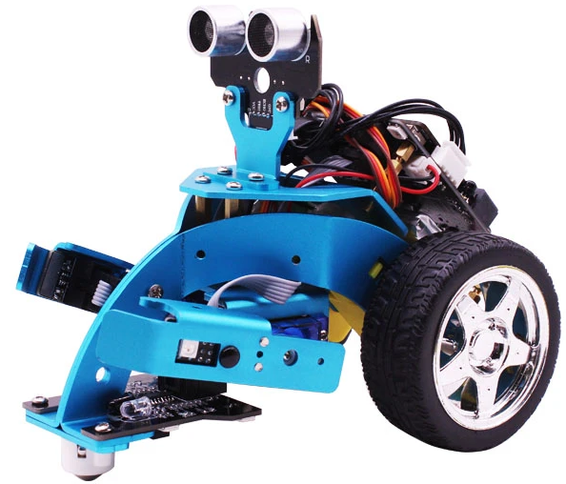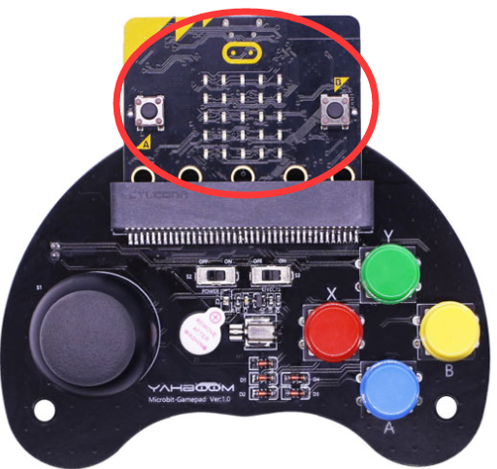
First, we need to download the Hellobot-Basic-code.hex to micro:bit board of micro:bit car. Open the power switch, you can see that the micro:bit dot matrix shows an smile, then display “1”. As shown in Figure 1.1.
we need to download the Handle-rocker-control.hex to micro:bit board of Handle. Open the power switch, you can see that the micro:bit dot matrix shows an “heart”, as shown in Figure 1.2.
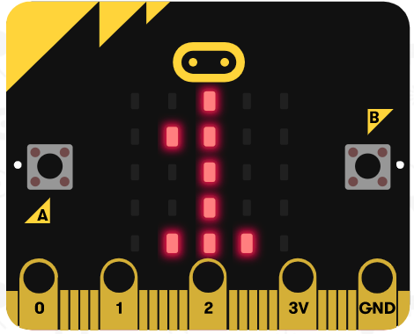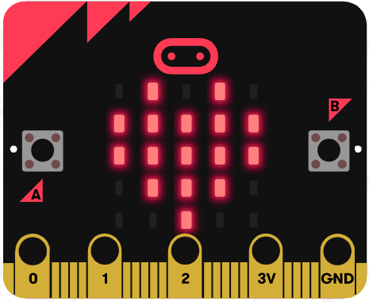
Figure 1.1 Figure 1.2
They will automatically pairing, then, we can start remote control the car by handle.
Push the rocker to forward -- Car advance
Push the rocker to back -- Car back
Push the rocker to left -- Car turn left
Push the rocker to right-- Car turn right
Press the button B1 -- left arm lay down
Press the button B3 -- left arm rise
Press the button B2 -- right arm lay down
Press the button B4 -- right arm rise

4.1.2 Handle rocker control basic Hellobot
First, we need to download the Hellobot-Basic-code.hex to micro:bit board of micro:bit car. Open the power switch, you can see that the micro:bit dot matrix shows an smile, then display “1”. As shown in Figure 1.3.
we need to download the Handle-gravity-control.hex to micro:bit of Handle. Open the power switch, you can see that the micro:bit dot matrix shows an “heart”, as shown in Figure 1.4.

Figure 1.3 Figure 1.4

They will automatically pairing, then, we can start remote control the car by handle.
Tilt handle to forward -- Car advance
Tilt handle to back -- Car back
Tilt handle to left -- Car turn left
Tilt handle to right-- Car turn right
Press the button B1 -- left arm lay down
Press the button B3 -- left arm rise
Press the button B2 -- right arm lay down
Press the button B4 -- right arm rise

